Roll no: 233065

Name: Pranav Mankar

ONLINE TICKET BOOKING SYSTEM

1. Create SRS Document (srs.txt)

2. Write Business entities and Business operation needed (business.txt)

3. Draw ER Diagrams

4. Write db.sql file

Creating New Repository for – ONLINE TICKET BOOKING SYSTEM

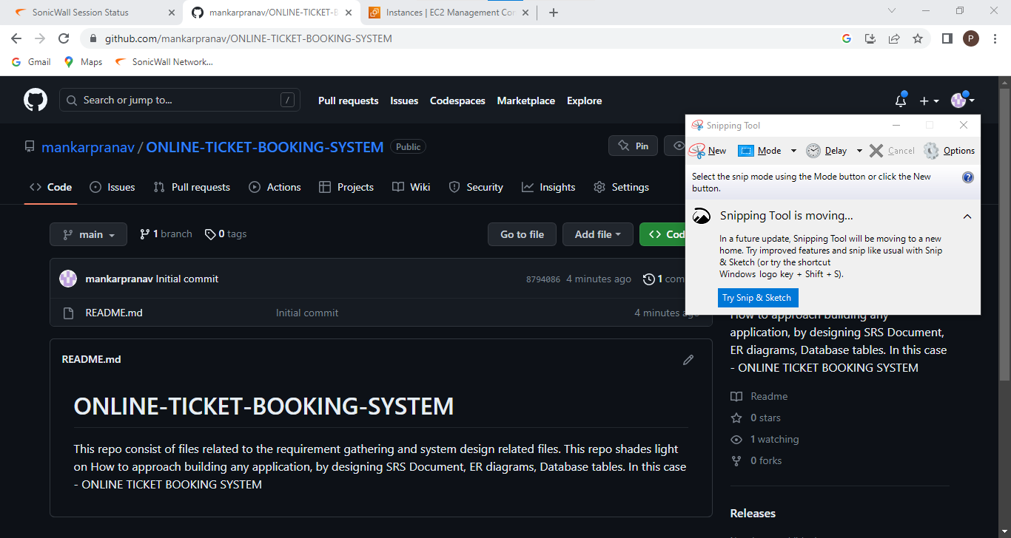

Cloning git Repo to local system

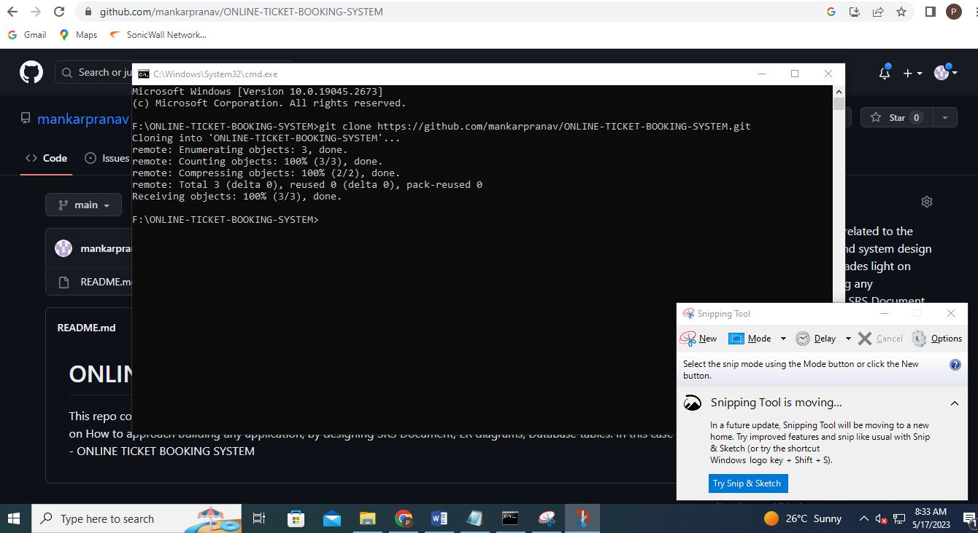

Now, upload all files created like – srs.txt, db.sql, er.diagram, business.txt files to repo created earlier.

For the same performing operation like –

1. **git status** (will check git status before push)

2. New files available

3. Now, add- **git add .**

4. Again, check status whether files uploaded successfully or not.

5. **git commit –m “any message” – will commit files to the repo.**

6. **git push** – will finally push new files to the repo.

7. Confirm push on github repo.

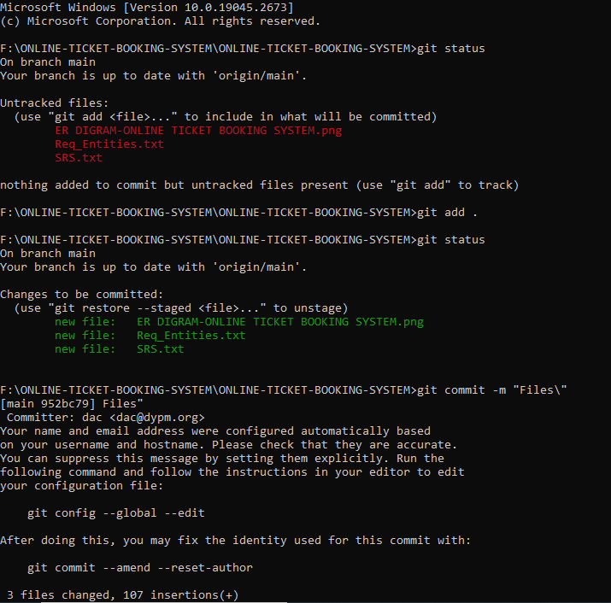

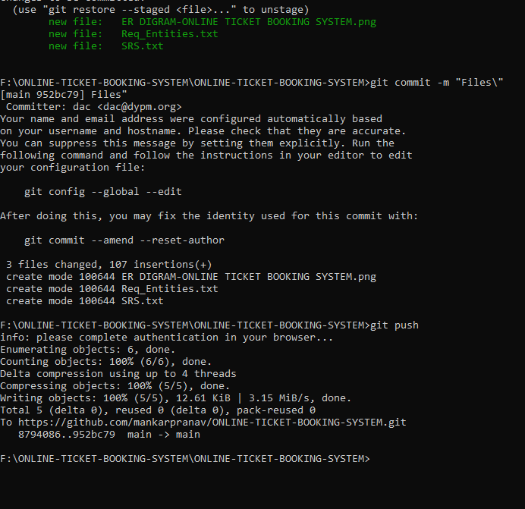

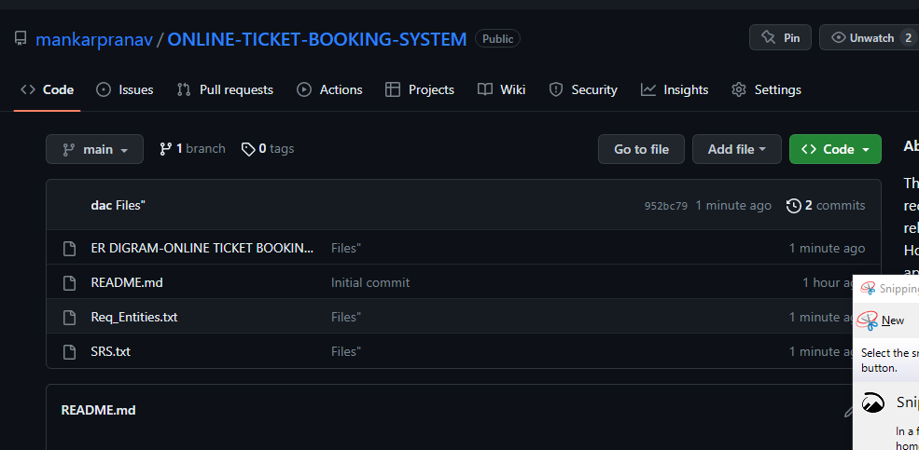

Docker ->

Adding webapp to repo

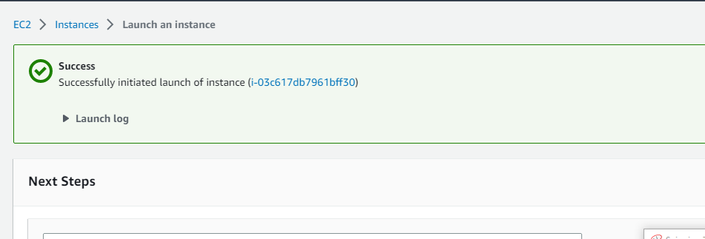

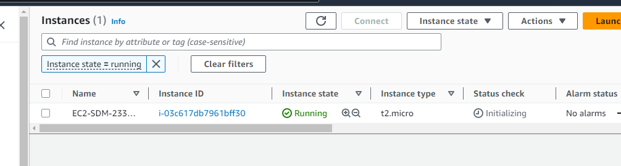

10. Started putty

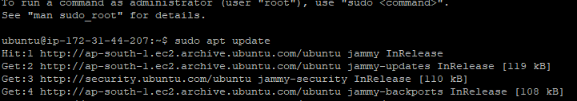

11.

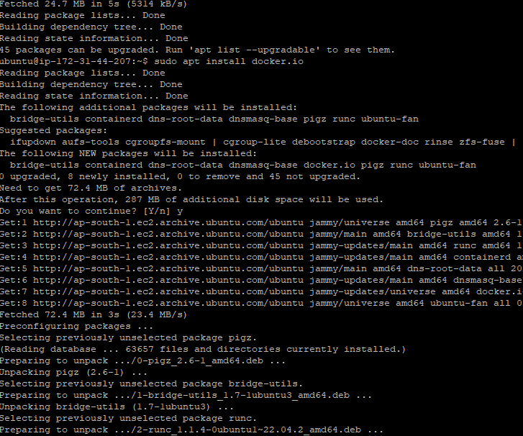

12.



13.

14. Security group firewall settings

